# Baby Block Design Document

Thomas Bunney

John Ingram

Daniel Balding

We use three functions in our main program, these are on separate flowcharts. They are as follows:

Void ShiftRight(int from, int moves)

Void ShiftLeft(int from, int moves)

Int FindNext(bool dir, int start)

Int FindSlot(char NB)

**Main program:**

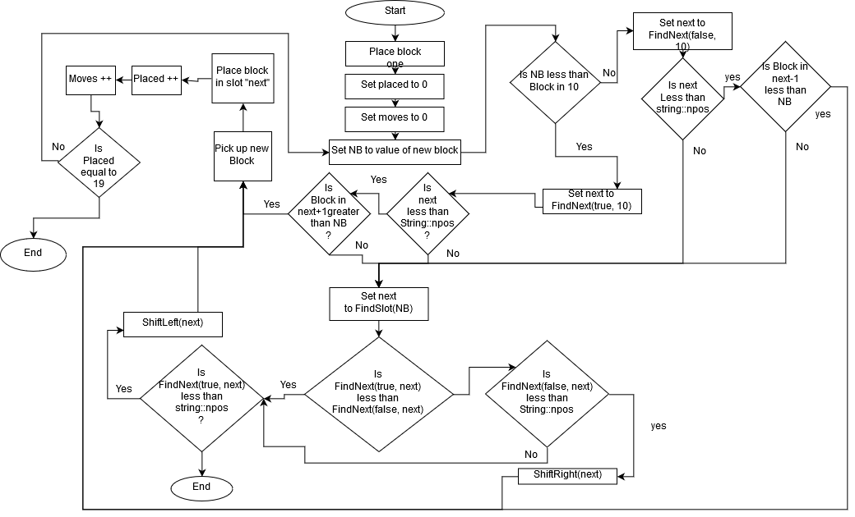

**ShiftRight:**

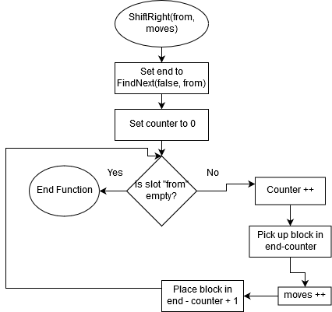

**ShiftLeft:**

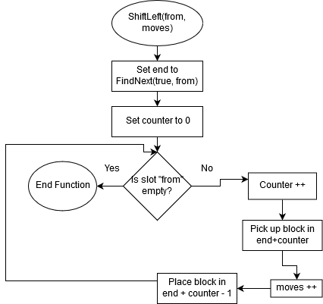

**FindNext:**

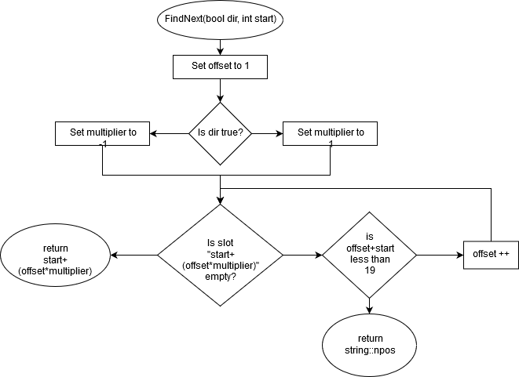

**FindSlot:**

